## Lesson 25 – Keyring Activity Sheet

This tutorial is based upon those created by Warwick University for their STEM outreach programme and simplified. The original tutorial along with many other excellent tutorials are available at

<https://warwick.ac.uk/fac/sci/wmg/about/outreach/3d_design_printing/cad_tutorials/>

**Step 1 Set your view to TOP**

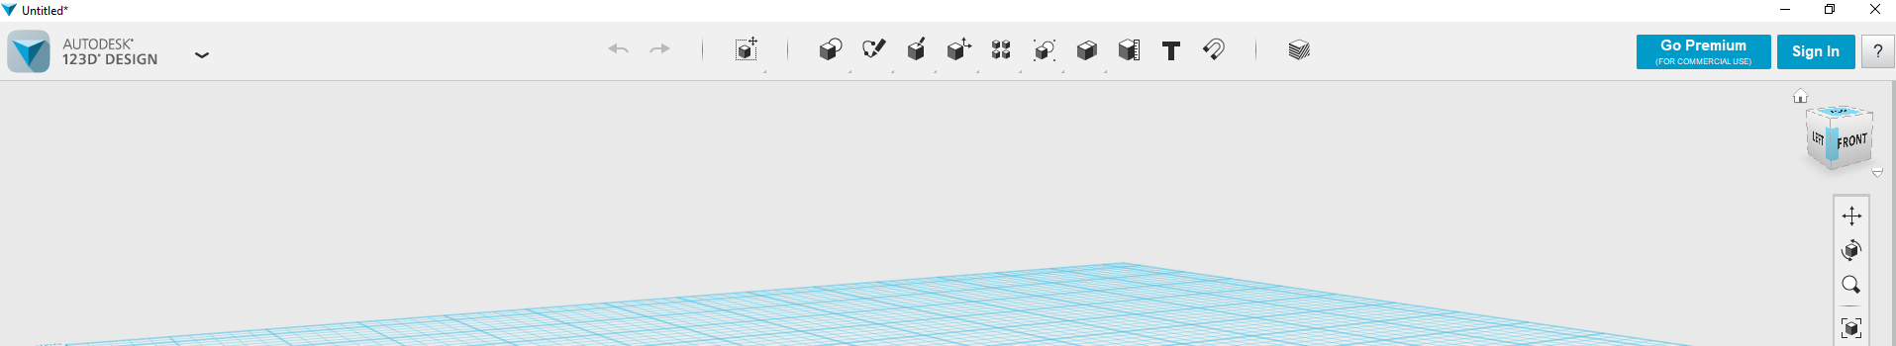

**Step 2 Draw a simple rectangle of 65 x 25mm**

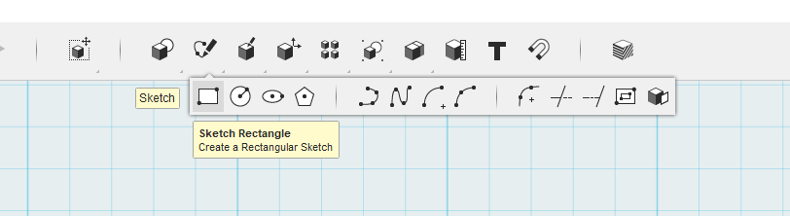

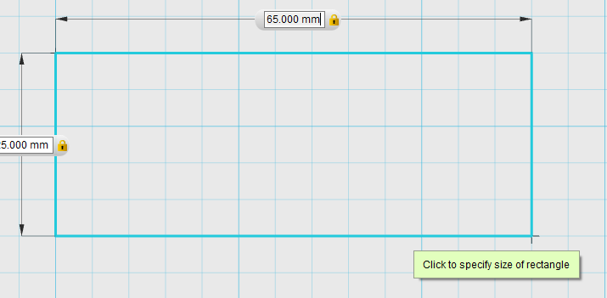

**Step 3 from the sketch menu chose fillets to curve the edges**

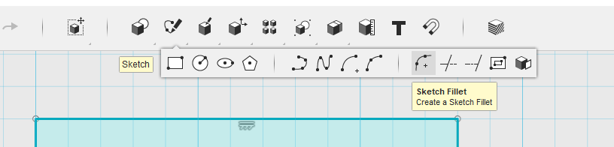

**Select the corner you wish to curve**

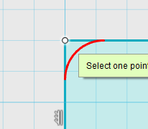

**And make the radius 6mm – do this for all 4 corners**

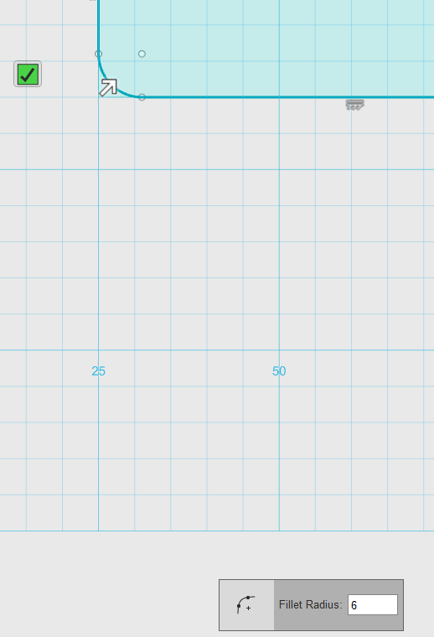

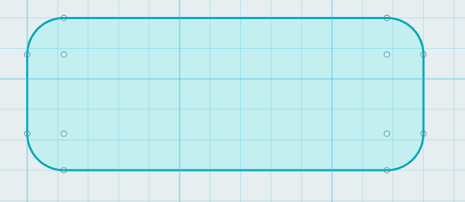

**Step 4 use CTRL C and CTRL V to make a copy of you shape**

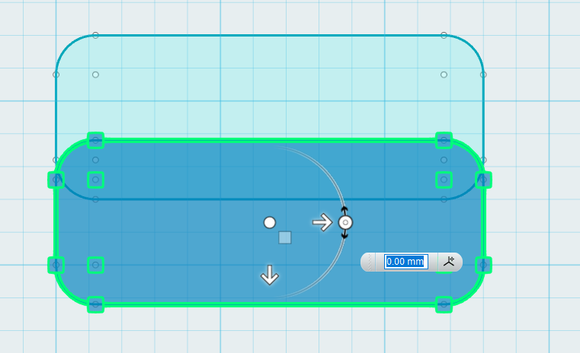

**And move it below the first**

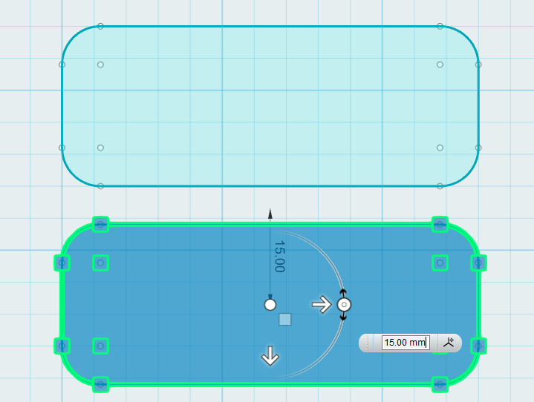

**Step 5 From the primitives option draw a 4mm circle where you want your keyring to mount**

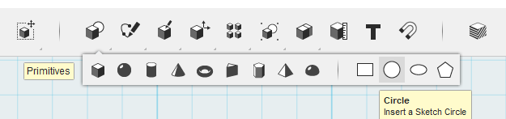

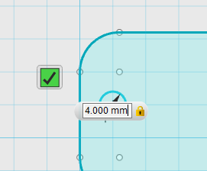

**Step 6 – From the construction menu select extrude**

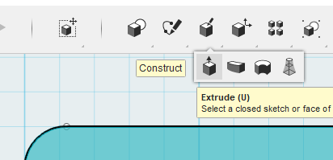

**Select the shape and extrude it 2mm up**

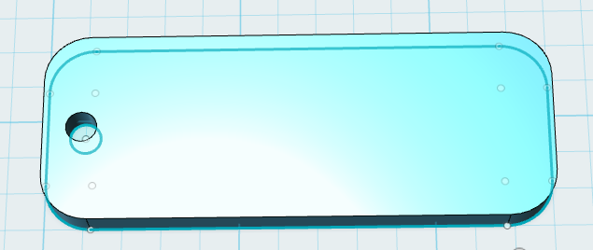

**Step 7 From the sketch menu select offset**

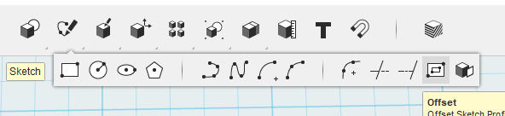

**And choose the outside edge of the bottom shape**

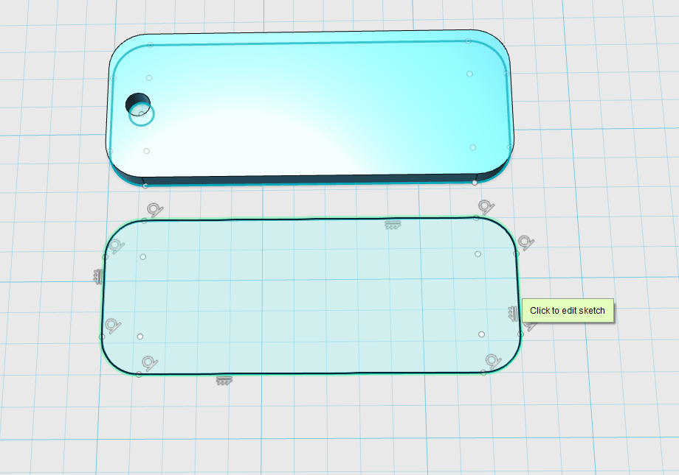

**Set the offset to 1.5mm**

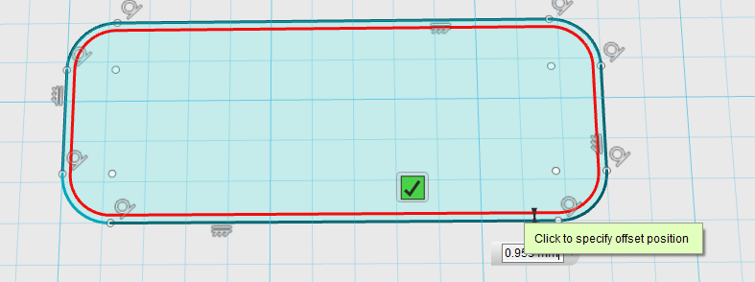

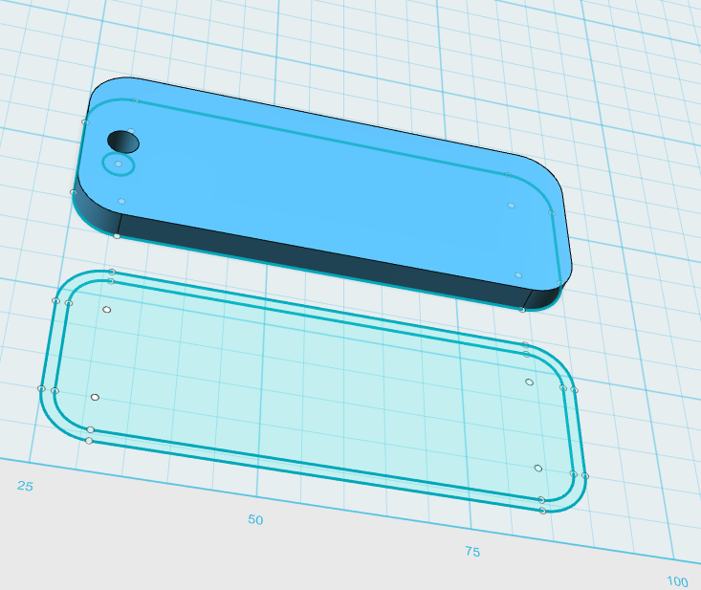

**Step 8 – Select the offset you just created and extrude it up by 1.5mm**

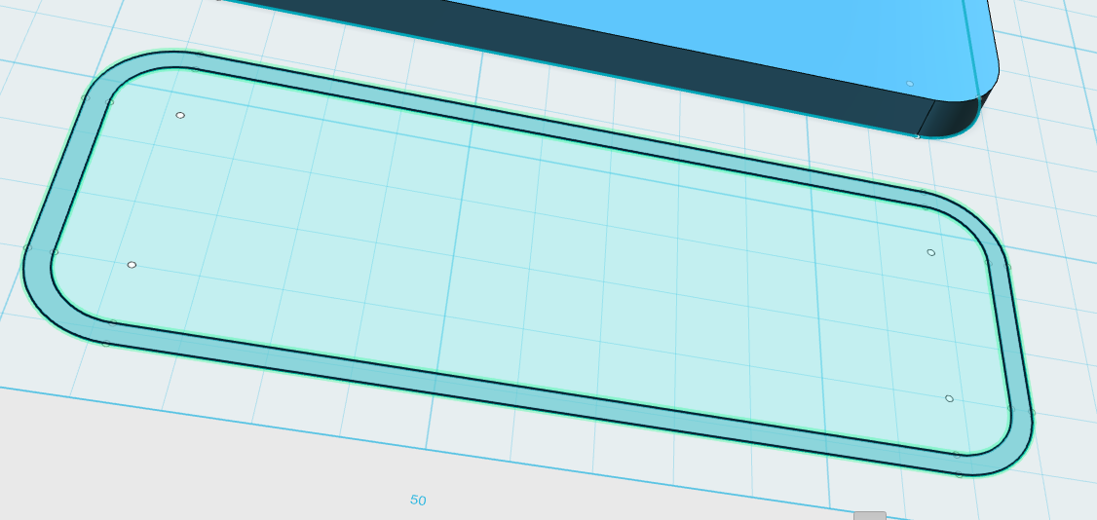

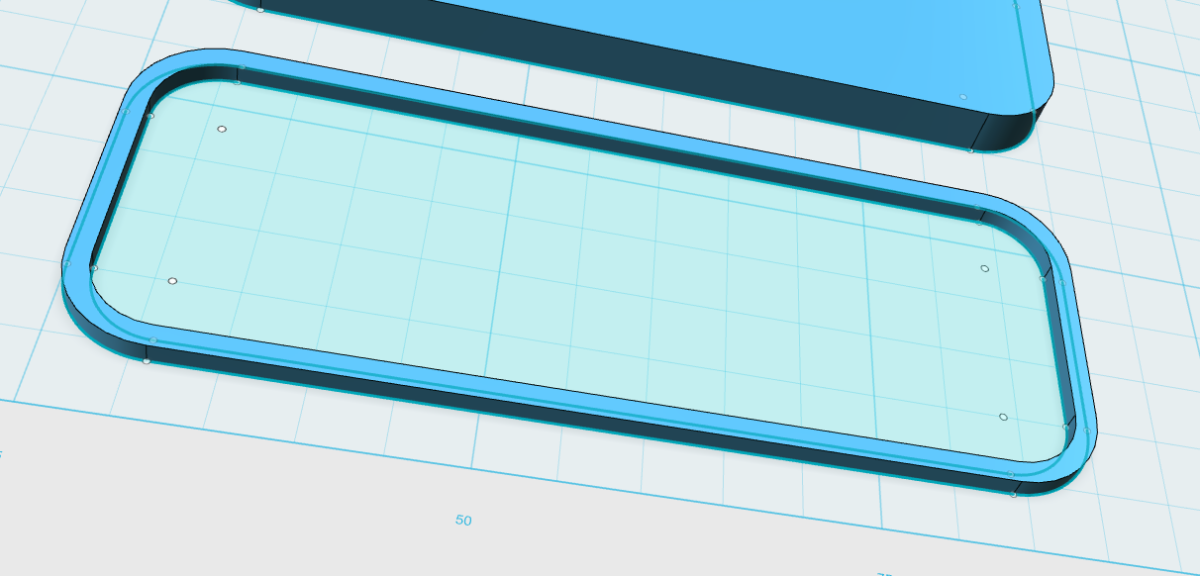

**Step 9 choose the snap tool**

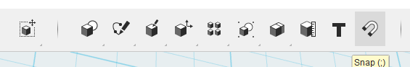

**Select your rim and then the top face to join them together**

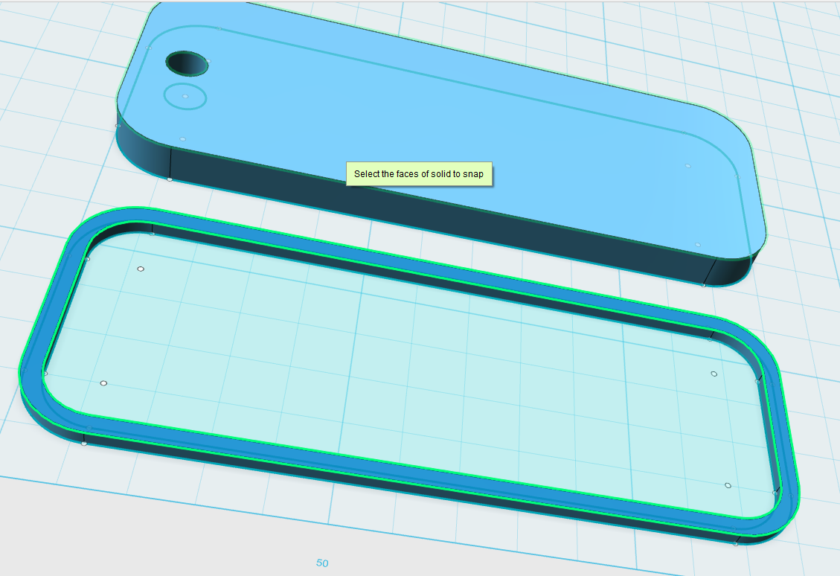

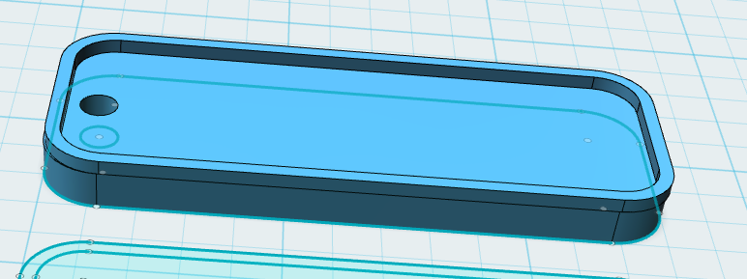

**Step 10 Choose the text option**

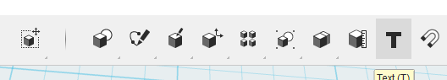

**Specify the starting point for your text**

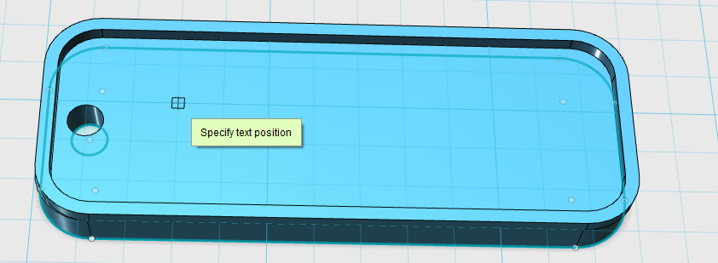

**Type, size and position before pressing OK**

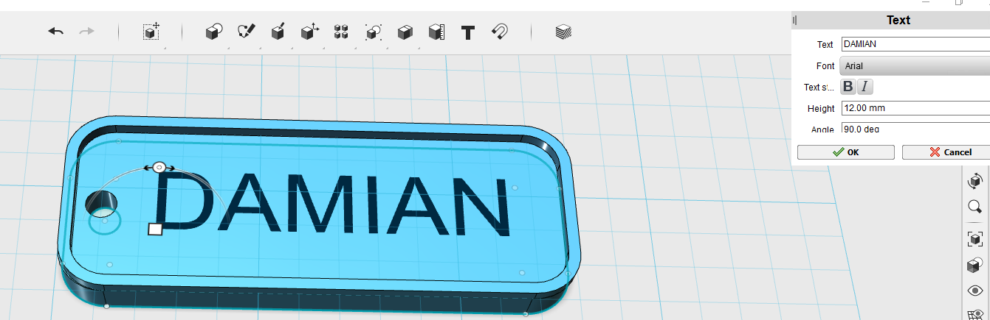

**Step 11 Select the text, click the cog and choose extrude text**

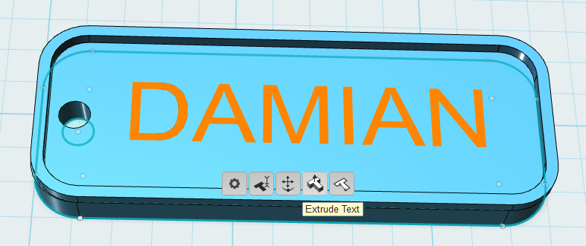

**Extrude up to 1.5mm**

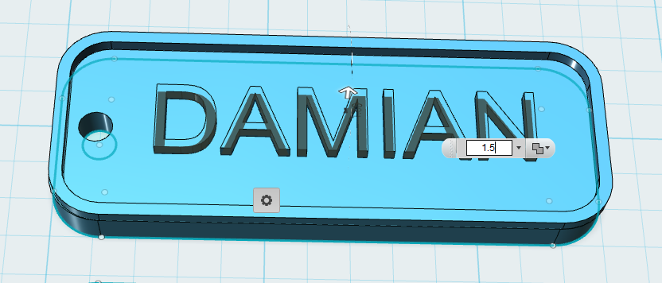

**Save your file to you PC and Export it as an STL file for printing**

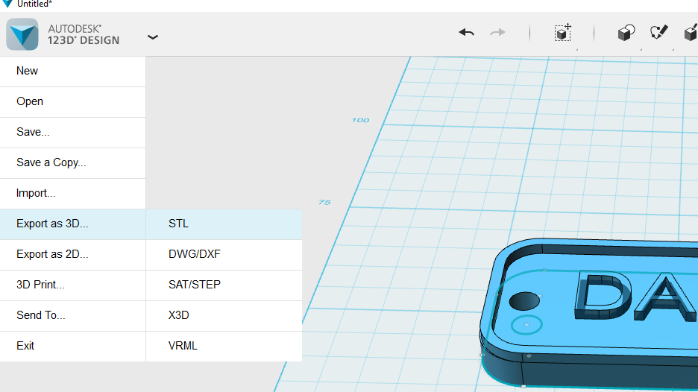

**Remember to combine the objects**

